HONG KONG INSTITUTE OF LANDSCAPE ARCHITECTS
PROFESSIONAL PRACTICE EXAMINATION 2025 - REGISTRATION FORM

Please complete this form and submit it together with other application materials via email to secretary1@hkila.com before 30 August 2025.

Please submit the registration package (including the Registration Form, payment record of Registration and Examination Fees and Practical Training Record) in ONE SINGLE PDF file. Separate files submission will NOT be accepted.

Part I.

Name of Applicant: (in English) (in Chinese)

E-mail: (must be given) Mobile:

Associate Membership No.: Date of Election:
(dd/mm/yy)

*Note: For advance information, applicants are required to have obtained at least 24 months Associate membership by 15 September of the year taking the examination, with effect from the application for admission to PPE 2025.

Note 1: For the working experience from 15 August to 15 September 2025, the candidate shall seek the supervisor’s approval to estimate the working hours to be distributed. The candidate shall maintain professional practice experience during this period, unless there are special circumstances.

Note2: All data must be entered using a keyboard. Handwriting is not accepted.

# If the candidate does not fulfill the qualifications mentioned above, the application will be disqualified, and no refund will be allowed.

Part II. Registration Types and Fee

Registration Types | Registration Fee
☐Written Examination | HK $2,400
☐Retaking Written Examination  Retake (For example, 1st retake/ 2nd retake) | HK $2,400
☐ Retaking Oral Examination  Retake (For example, 1st retake/ 2nd retake) | HK $2,400
*Note: Please attach last exemption notification for written examination

Part III. Summary of Professional Practice Experience:
(Please list below in chronological order, the names and addresses of employers, duration and lengths of employment, including ‘year out’ if applicable. Continue on a separate sheet if necessary.)

 | Name of Employer:  (Current to past) | Position: | Date: from  (dd/mm/yy) | Date: to  (dd/mm/yy) | Total length:  (months)
1.
2.
 |  |  |  | Total

Applicant’s Signature: Date:
(dd/mm/yy)
Page 1 of 2 Aug 2025

PAYMENT METHOD

1. Payme  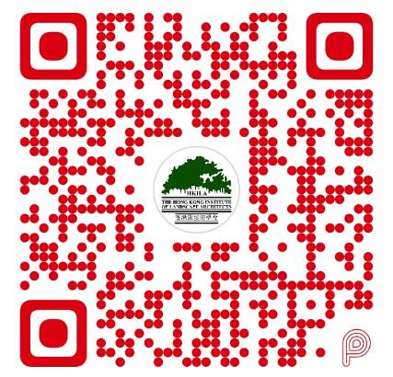 | 2. PayPal  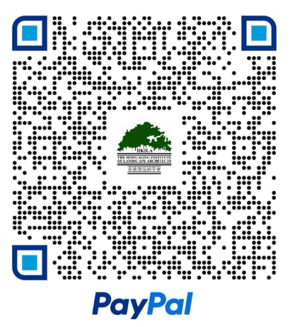

Steps:
- Scan either paycode (Payme or PayPal)
- Confirm payment is made to ‘The Hong Kong Institute of Landscape Architects’.
- Enter the payment amount with your name and member no. in the remarks according to the format below.
[Name + membership no. (PPE)]]
Example:
Chan Dai Man GXXX ppe 2025
- Email the renewal form and CPD record to secretary1@hkila.com. A screen capture of payment is an option,
but this will help us verify earlier.

3. FPS / ATM
Please email us (secretary1@hkila.com) the deposit confirmation with your name and member no. after you make the transfer.
Payee: | The Hong Kong Institute of Landscape Architects
Bank name: | The Hongkong & Shanghai Banking Corporation
Bank code: | 004
Bank account: | 033-211459-838

- Cheque
Please make a cheque payable to ‘The Hong Kong Institute of Landscape Architects’ and send it to West Wing 2/F, 822 Lai Chi Kok Road, Cheung Sha Wan, Kowloon, Hong Kong.

Email secretary1@hkila.com to help verify.
- Deposit confirmation
- Screen capture of payment with name and membership no.

For a membership payment enquiry, please contact us using the information below.
Email：secretary1@hkila.com
Tel.: 2896 2299
Whatsapp: 6504 2702

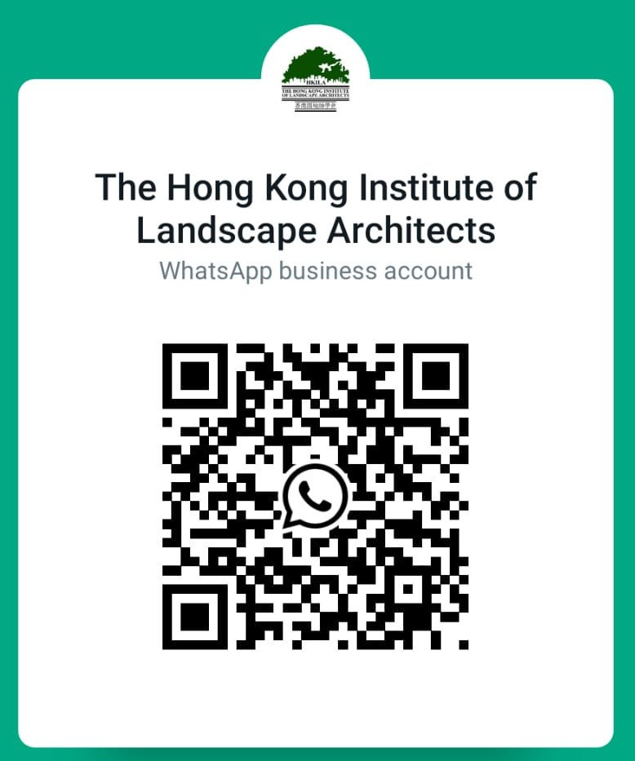

Page 2 of 2 Aug 2025

