 | Section 1  Tree Identification and Knowledge | Section 2  Syllabus of Admission Assessment for HKILA Accredited Arborists 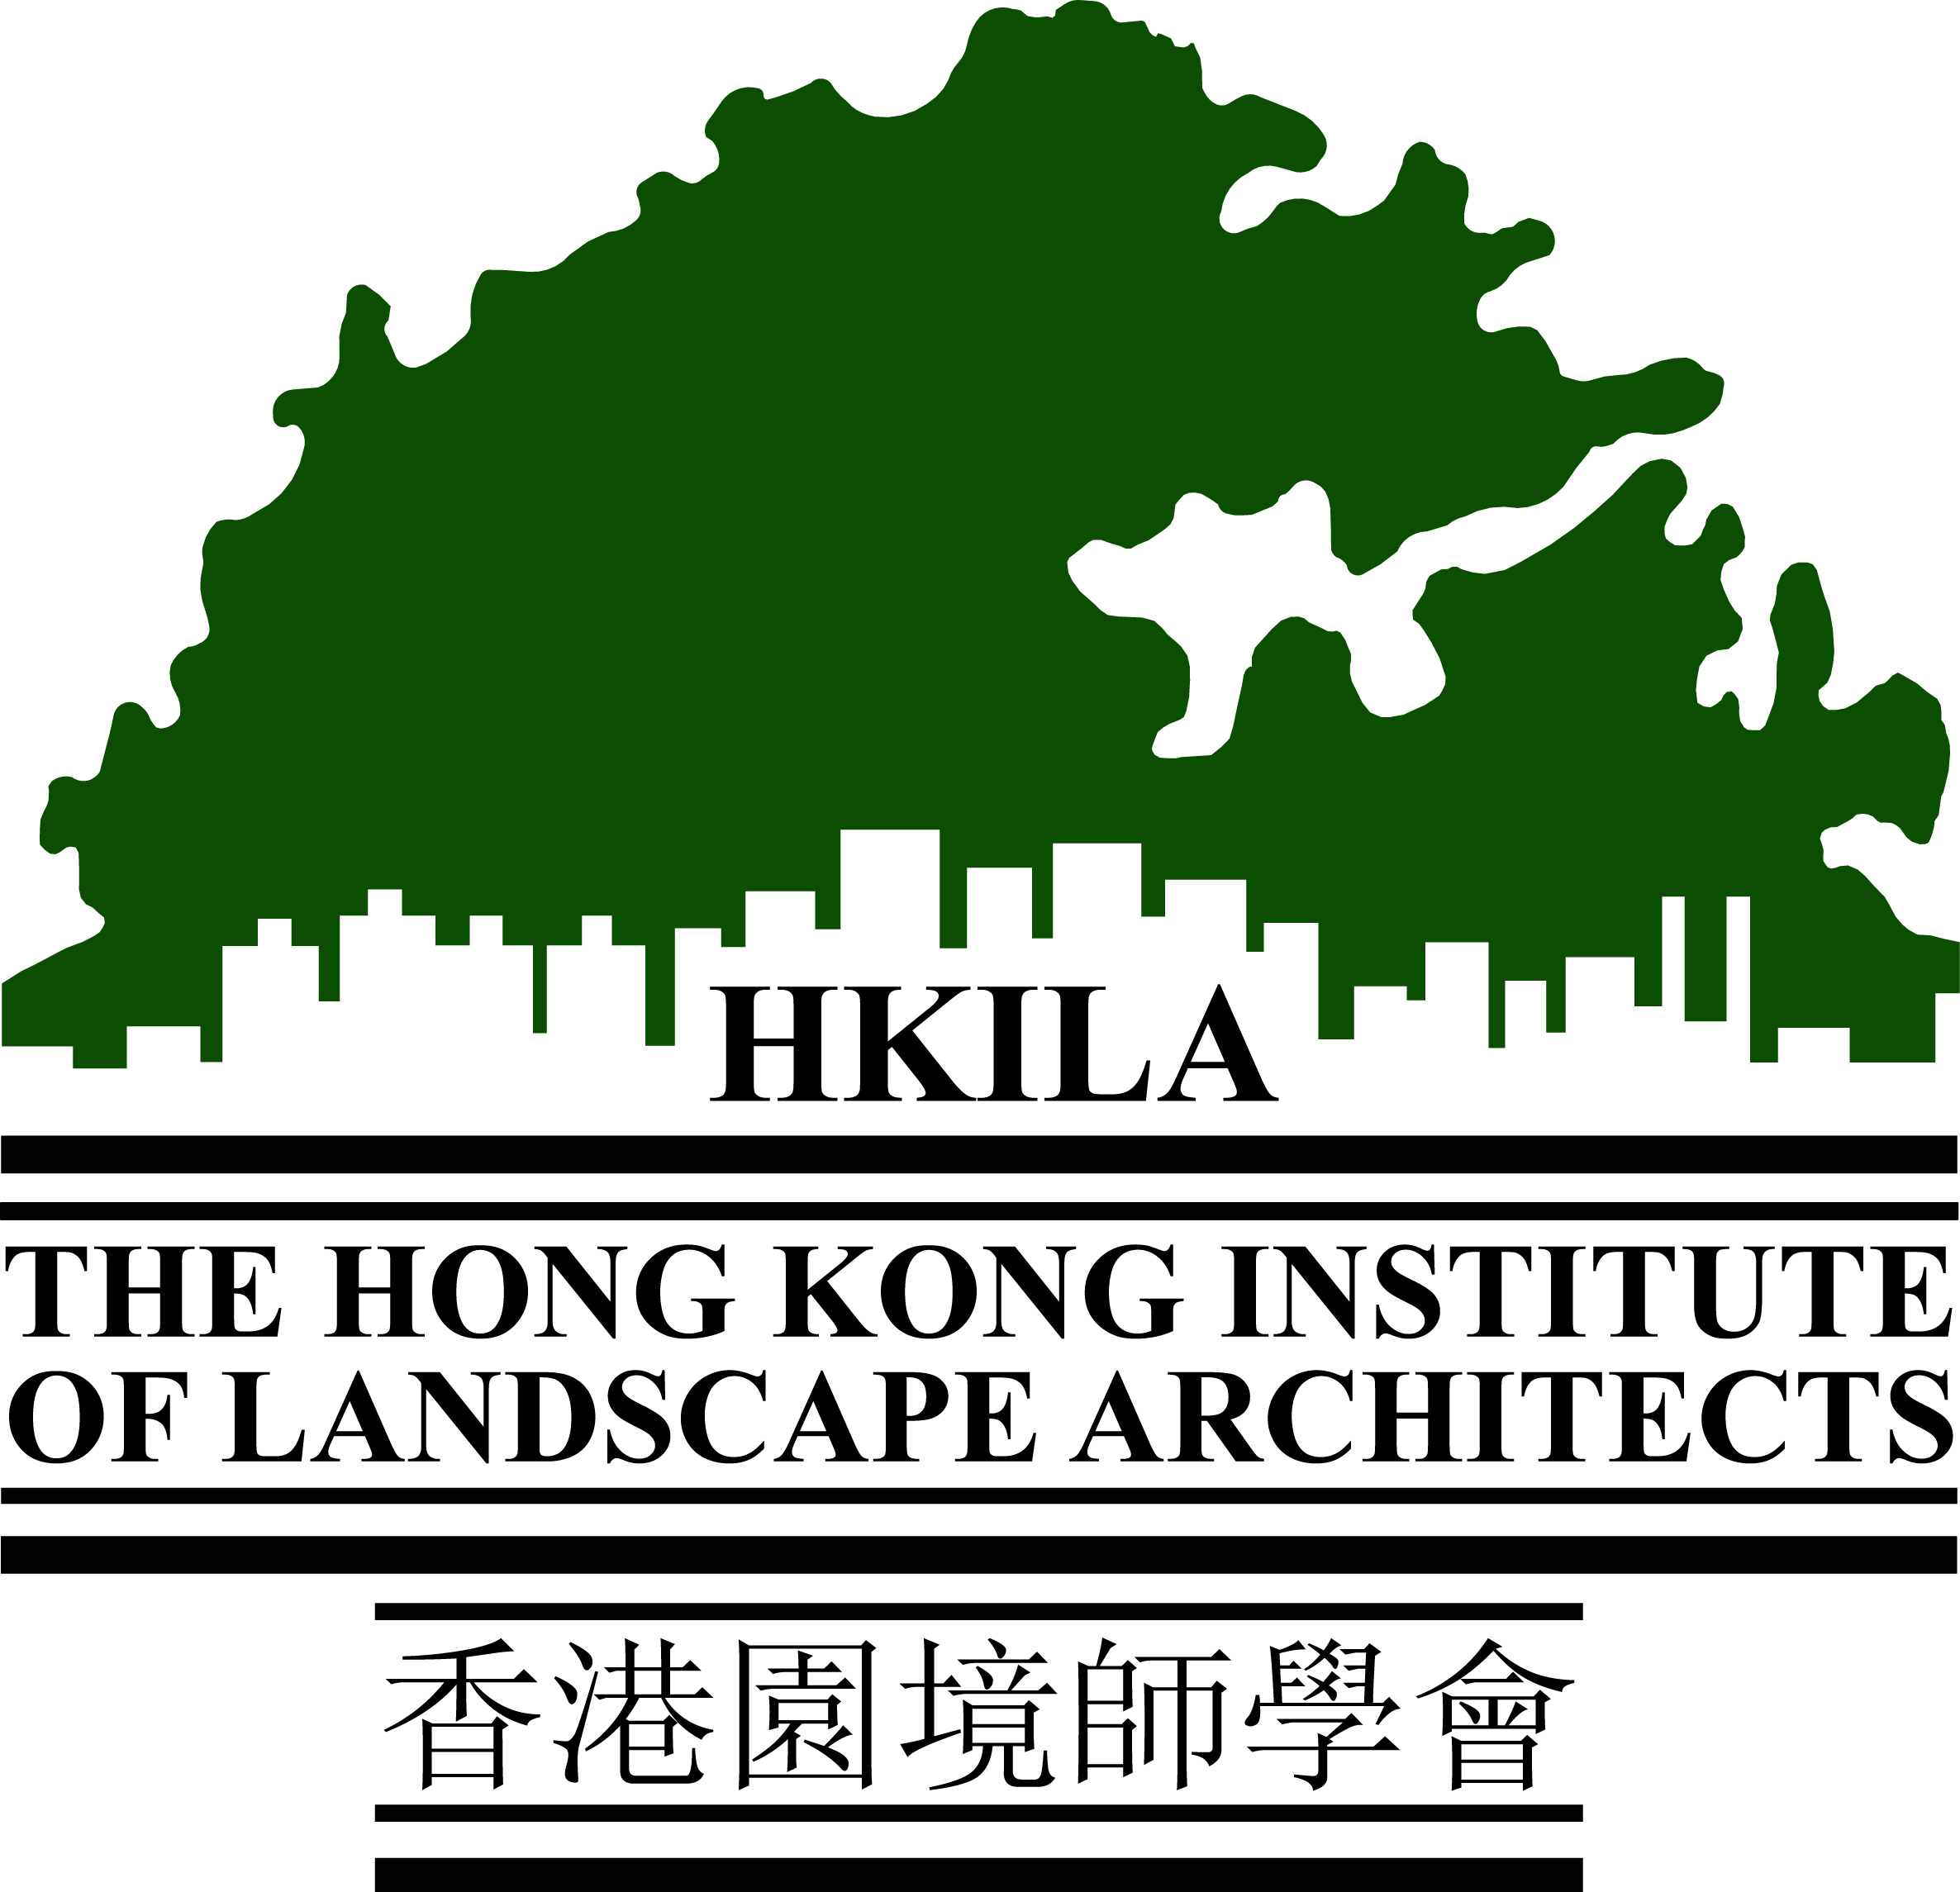  Tree Risk Assessment | Section 3  Safety at Tree Works | Section 4  Professional Conduct, Ethics and Liabilities | Section 5  Arboricultural Practice and Tree Care
Scope of Assessment | - Identification of 100 common tree and palm species  - Characteristics and uses of various tree species | - Principles and procedures for tree risk assessment  - Common tree defects  - Common local tree related pests and diseases  - Theory, advantages and limitations of decay detection equipment (e.g. resistograph, tomograph) | - Roles of tree work supervisor  - Safe system of work  - Work at height  - Personal protective equipment (PPE) for tree works | - Professional roles and responsibilities  - Ethics for Accredited Arborists  - Liabilities under contract, tort and statutes | - Pruning practice  - Tree care during construction  - Practice of tree transplanting  - Tree planting and post-planting care  - Tree surveying practice
Reference Materials | - Tree list on HKILA webpage under Accredited Arborist page | - Tree Risk Assessment and Management Arrangement (GLTMS)  - Note on Common Wood Decay Fungi on Urban Trees of Hong Kong (GLTMS)  - Manual on the Management of Brown Root Rot Disease (GLTMS)  - Pictorial Guide for Tree Maintenance to Reduce Tree Risk (GLTMS) | - Guidelines on Arboriculture Occupational Safety and Health (GLTMS)  - 5 Steps to Information, Instruction and Training  (Labour Dept.)  - Safety at Work - A Guide to Ladders and Elevated Working Platforms Training  (Labour Dept.)  - Guidance Notes on Safe Use of Power-operated Elevating Work Platforms  (Labour Dept.)  - American National Standard for Arboricultural Operations – Safety Requirements (ANSI Z133), 2017  - Technical Guide 1: Tree Climbing & Aerial Rescue, Arboricultural Association, 2020 | - Code of Ethics and Conduct of Accredited Arborists Listed Under The Hong Kong Institute of Landscape Architects (HKILA) | - Guidelines on Tree Preservation during Development; Guidelines on Tree Transplanting; Management Guidelines for Mature Trees; Pictorial Guide for Tree Maintenance (GLTMS)  - DEVB TC(W) No.5/2020 Registration and Preservation of Old and Valuable Trees (Dev. B.)  - Section 25 of General Specification for Building (ArchSD)  - Section 3 & 26 of General Specification for Civil Engineering Works (CEDD)  - DEVB TC(W) No.4/2020, Tree Preservation (Dev. B.)  - Guidance Notes on Tree Preservation and Removal Proposals for Building Development in Private Projects Compliance of Tree Preservation Clause under Lease (LandsD)

